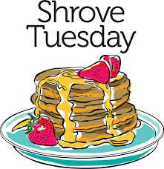

**Come join us for a delicious pancake dinner hosted by SAOTS EYC on Tuesday, February 13th from 5:30-7:00 pm in the parish hall. You will have a choice between plain pancakes, blueberry pancakes, or chocolate chip pancakes with an assortment of toppings of your choice available at your table. Dinner will be served at the tables by our EYC youth. We will also have eggs, sausage, bacon, biscuits, and more. We will also have coffee, hot tea, cold tea, water, and lemonade as your choice of beverages.**

**We will have a Mardis Gras themed night including a photo booth, $1.00 raffles-cash only (three drawings throughout the night with a chance to win a local restaurant gift card). We will also have a children’s craft and activity station. This event will be fun for all ages. Also come check out our EYC table where you can learn more details about our New Beginnings Youth Conference at Trinity Center in April. We will be accepting donations for our trip to cover transportation costs and participation fees.**

[**SAOTS Shrove Tuesday Pancake Dinner RSVP Link**](https://www.signupgenius.com/go/20F0A49AAAD22A1FA7-47403200-21324)

**If you have any questions, please contact Stephanie Rieman at 910-431-7898 or** [**eycstandrewsonthesound@gmail.com**](mailto:eycstandrewsonthesound@gmail.com)

